**Summary of Most Important Findings**

SuperSportz is an app that allows users to find other people in their area to play pick-up games of recreational or competitive sports. Our managerial decision problem was to figure out if we would launch the app or not. We then conducted research to help answer the following market research questions:

* What is the consumer’s level of interest?
* What sports should we include in the app?
* How difficult is it to find people to play sports with?
* Should the app be more recreational or competitive?
* What features should we include in the app?
* How much are consumers willing to pay?
* Who is the target market for SuperSportz?

After analyzing the following data and surveying over 200 people, we concluded that SuperSportz should be launched.

After distributing the survey, we came across many opinions and trends that both surprised us, and reassured us of the success of SuperSportz. Many of the features we initially thought would be the most beneficial or would receive the most positive responses ended up not actually affecting peoples’ willingness to download (WTD) the app. One of first questions in the survey was *how frequently do you play sports?* (Q5). The respondents then had the option to choose a value between multiple times a week and never. We originally thought that this question would be very significant in determining if respondents would also download SuperSportz (WTD). What was very surprising is that this question has very little significance in determining WTD. We used a regression to test this relationship and it told us that frequency of playing sports had a p-value of 0.3 when it came to WTD. It was very surprising to learn that this is not significant and made us curious to find out what would end up being significant.

The biggest determination of WTD is the user’s estimation of how often they would use the app. This may seem like common sense, but that’s how we thought the frequency of playing sports would be. From the regression, we found that the more often people say they will use the app, the more they are willing to download the app. This tells us that if users see some value, or one personal use of SuperSportz, they will download and become customers. So, the question is then what can SuperSportz do to bring value to the consumer.

To test this, we ran a conjoint and gave respondents the chance to choose between two different options for the app and its features. This gave us very valuable data that helped us to better direct our efforts to our target market. Originally, we had the same mindset as our number one competitor, BVDDY. We thought that users would love an app that combined the ease of making new friends with a new way of playing sports. In our minds, we thought of a set up like that of Tinder, allowing users to move quickly through potential friends. After the conjoint and some regression, we realized that most users do not care about making new friends, they just want an easier way to play sports and set up more games. This helped us to better layout the app to their preferences and ask more questions to specify what services they want.

A final finding of ours that is very surprising is that users do not prefer one sport over another. We thought that consumers would love certain sports over others, and they would prefer these certain sports to be in the app. From our tests, we found that users have no preferred sports. They care more for a wide variety rather than focusing on a few key sports. The target market that we could determine by the cluster analysis are those people who already play sports or want to be playing sports more than they already do. We then considered why these people are having problems playing the amount of sports they want and found that most of them either have friends that are too busy or hard to contact, as well as friends who do not enjoy the same sports as they do.

By conducting this survey and analyzing the results we were able to optimize the app SuperSportz to best solve the target market’s pain points, as well as understand how to promote the app to the right demographic. The following report explains the research and tests we did to address our market research problems while addressing our managerial decision problem.

**Detailed Findings**

In our many tests, we used willingness to download (WTD) as our dependent variable. We used WTD since it is logical that SuperSportz success depends on whether people are willing to download the app. To better understand which variables affect the consumers’ WTD, we ran multiple bivariate linear regression on different questions. We ran ANOVA, correlation, Chi-squared, and single linear regression tests for the different variables.

From the survey that we conducted, we looked at the relationship between our dependent variable, *likelihood of download* (Q27) with the following independent variables: *frequency in playing sports/activities* (Q5), *favorite sports to play* (Q3), *how often they would use this app* (Q33), *how many of their friends play sports* (Q12), *difficulty of finding others to play sports/activities with* (Q9), *who they play sports with* (Q6), *are they interested in playing competitive sports* (Q15), *what would be the biggest motivation for them to use this app* (Q31), *and what is their biggest challenge in finding others to play sports with* (Q10).

**Research Objective: Level of Initial Interest**

As we tried to better understand the consumer’s level of interest we wanted to first understand how frequently someone played sports and if that affected whether they would download SuperSportz. We were surprised to find that there is no correlation between how frequently someone plays sports and how likely they are to download the app. (t-statistic=1.0193 and a P-value>0.05). This was one of the first relationships we decided to examine since it seemed like those who played more sports would be more likely to find a need for an app like SuperSportz. However, we can now see that there are other variables that affect consumers’ WTD much more. Because we were wrong about what we thought to be a logical result, we were very curious to continue in our analysis to better understand what the consumer is interested in an app like SuperSportz.

The next relationship that we examined to better understand the consumers’ level of interest was the correlation between how often people estimate they would use this app and their WTD. We found that people who estimate they will use SuperSportz more often are also more likely to download SuperSportz (T-statistic=8.8, P-value < 0.05). This specific test is important as it proves that those who download the app are actually going to use it frequently and not just let it sit, hidden in their phones. (Figure 1) We can see that there is interest in using the app, and the next obvious step was to question and test what exactly would make SuperSportz useful in the eyes of the consumer.

Figure 1

**Research Objective: What Sports to Include in SuperSportz**

We wanted to know what sports people played and wanted to see on the app; however, when we questioned users about their favorite sports and if it affected their WTD, the results were interesting because they were different than we assumed. The survey that we distributed gave people the option to select what sports they played, and from that data we made a numerical summary of the sports that were most frequently selected. When looking at the sports that people play most often and their WTD, and how the one affected the other, we found that running, hiking, volleyball, and biking were the most popular sports. However, our results from the ANOVA showed that if people played any of the mentioned sports, it would not affect their WTD (F 0.005, 2.987, 0.445, 0.224, P-value >.05). This can help us understand that people are not sensitive to what sports are offered, but to other aspects such as sociability and quantity of sports. It also showed that users are not as into the big, popular sports (football, basketball, baseball, etc.) and we thought they would be, but are looking for anything to be active.

To verify this idea of people not caring what sports are included as much as the opportunity to play a quantity of sports and more often, we tested why people would or would not use SuperSportz. The main response options included: to meet new people, to play more sports, and to learn new sports. After analyzing each of these unique variables the only variable that affected the consumers WTD was to play sports more often (F 20.097, P-value < 0.05). By knowing that those that want to play sports more often are those who would use SuperSportz we can understand how to advertise for SuperSportz and what people are looking for in SuperSportz. We can see that those who would download SuperSportz are those who are looking to be active more frequently (Figure 2). Understanding what people are looking for is also valuable because we can make our app more specific to the consumer and help us pivot away from the competition.

Figure 2

**Research Objective: Difficulty in Finding Others to Play Sports With**

We also wanted to understand the pain point that people have when it comes to them finding others to play with, so we could understand our target market. We initially thought that the people who would download SuperSportz probably didn’t have many friends who played sports, but once again, we were surprised to find that WTD had no significant relationship with how many of the consumers’ friends played sports (F-statistic=0.009 and a P-value > 0.05.) Since there doesn’t seem to be a problem with a lack of friends who play sports we wanted to test if people found that their current friends were not playing enough sports. Just from the survey, we found that many people do in fact have difficulty finding others to play sports with, though many of their friends do play sports. We tested the relationship between these difficulties and the consumers WTD. We found that there was in fact a significant relationship between this variable and peoples’ WTD. From the test, we can infer that those who find it more difficult to find others to participate in activities or play sports, are the same people who are more likely to download this app (F=14.128, P-value < 0.05). This helps us understand our target market and the pain point that we are solving is correct. We can gather from this that the people who want to meet up with others to play sports may be looking for team sports or are looking to play more sports than they can with their current friends (Figure 3).

Figure 3

To back up our understanding of this pain point of not having enough friends that want to play sports or playing enough sports we considered the motivations that people would have to download this app, and if they truly find it difficult to find people to play sports with. The survey asked what peoples’ motivation to download SuperSportz would be and gave them the options; getting in contact with others is the hardest part, their friends are busy and can’t play when they want to, it is hard to find those interested in their same sport/activity, and they don’t usually like reaching out to others. We found that all but the last option affected peoples’ WTD. If consumers find it difficult to get in contact with others they are more likely to download SuperSportz (F=5.652, P-value < 0.05). Also, if the consumers’ friends are busy and cannot play sports when they want to, they are more likely to download SuperSportz (F=13.272, P-value 0.000). People are also more likely to download SuperSportz if they find it hard to find others interested in their same sport or activity (F=5.517, P-value < 0.05). The only motivation that will not actually lead them to download the app is if they usually don’t like reaching out to others (F=0.23, P-value > 0.05). People who do not like to reach out to others would also not want to download an app that helps them connect with others to play these sports. We can learn that there are multiple motivations for downloading SuperSportz and a common theme is that people are wanting to play sports more frequently than they do currently with the friends they have (Figures 4,5,6).

Figure 4

Figure 5

Figure 6

**Research Objective: Competitive vs. Recreation Sports**

Once we learned that there is an interest in SuperSportz and that people are willing to download it to play sports more often, we needed to then understand if they were looking for more competition or just recreational. We found that those who want to download SuperSportz are also those who want to play competitive sports (F 14.128, P-value<0.05). This relationship shows that the target market would be those who are interested in playing competitive sports and finding others with this same passion, and not necessarily lessons or friendships like we previously thought (Figure 7). We are looking at people who want to play sports with other sport lovers. However, since the sports that were most popular were more recreational; we find that SuperSportz can be targeted all types of sports and all types of competitive levels.

Figure 7

**Research Objective: Features to Include, Layout, and Price**

At this point in our survey and testing, we wanted to introduce SuperSportz to the consumers. To further understand if we should launch SuperSportz, we needed to answer the question; what features should we include in the app? On the survey, we showed them a potential picture of the future app and then gave them a description. We then ran a conjoint to test different versions of the app. A conjoint is a test that presents respondents with controlled set of attributes that could potentially be a part of our product. These attributes come from a bank of multiple options that we created to include each possibility for the major parts of out app. In the test, each respondent was shown two options of attributes for the app, and they were prompted to choose the app they would rather use. The test then analyzed the valuation of each individual element and which attributes/features are most important to the user. Once we knew how important they viewed each attribute of the app, we could better design SuperSportz to their preferences. Each respondent saw two versions of the app that potentially differed in App Layout, Features, Privacy Status, Skill Level, and Price (Figure 8).

Another great benefit of the conjoint is the Market Simulator we ran afterwards. This simulator allowed us to see how our respondents/the market would respond to certain changes in pricing, features, or other attributes. The Market Simulator then gave us a percentage of those who would use our product compared to a different variation and let us compare how our app would do compared to our competition.

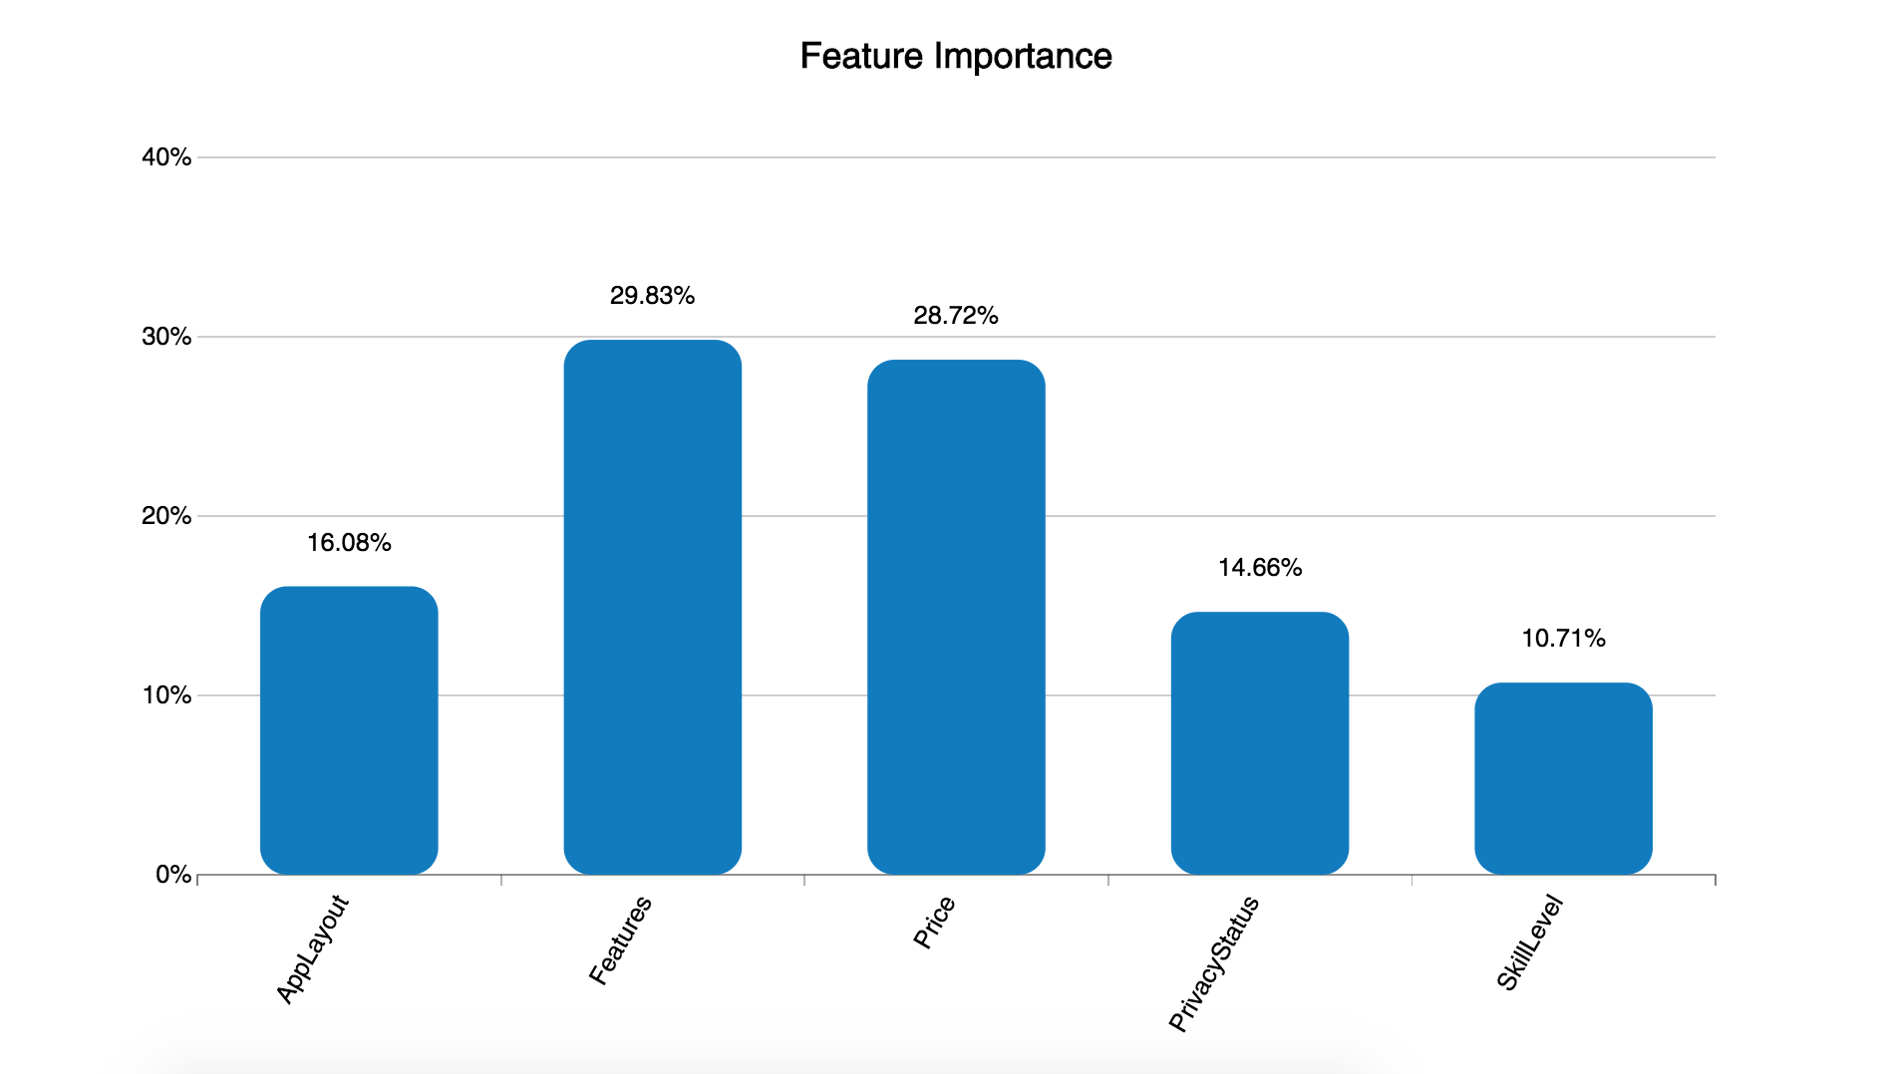Figure 8. Importance of each attribute to consumers

Originally, when we thought up SuperSportz and how the app would look and function, we had a few specifics in mind. We thought the app would look like Tinder, with swiping capabilities to quickly progress through potential players. We thought that people would use the app to set up pick-up games with other players of any skill level. We also envisioned that each players profile would be public to every other user. Finally, we knew that our target market of college students, would only use the app if it was free of charge (Figure 9). In our minds, this was the perfect version of SuperSportz. But when we ran the conjoint, our version only ended up with 61% likeability compared to the ideal. We realized that a few of these were actually the opposite of what people wanted.

Original/Bvddy Layout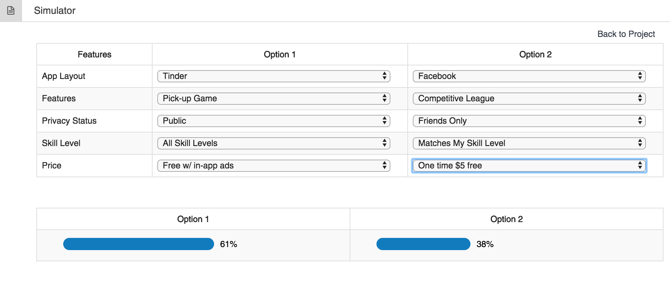 Figure 9. Original layout/Bvddy vs worst combinations for SuperSportz

The above is not only how we envisioned the app, but it is how others have envisioned it as well. Our largest potential competitor is an app called BVDDY. This app’s goal is to make new friends through sports, even their slogan is “find your sports buddy.” BVDDY is set up exactly like option 1 and we can see that this doesn’t lead to maximum market share. One important way that SuperSportz will be different than BVDDY is that SuperSportz will focus more on the sports and playing games, verses trying to make new friends. We know this will give us an advantage because we learned in our previous regressions that consumers WTD is based more on playing sports than making friends.

When envisioning the app at the very beginning, we were correct on the two most important attributes of the app. Respondents said that feature and price are the most important to them, and they agreed with using the app mainly for pick-up games and that the app should be free with a few in app ads. App Layout and Privacy Status came out as the next two important attributes, which we had wrong ideas about both. Here, respondents noted that they want the app to have more of a Facebook look, with a continuous scrolling instead of swiping. Respondents also like their privacy and want unknown users to request their friendship before viewing their profile. Lastly, we discovered that respondents only want to play with those that are their same skill level. This ideal app resulted in a 95% acceptance rate, which is 34% higher than what we thought would be effective (Figure 10).

Ideal Layout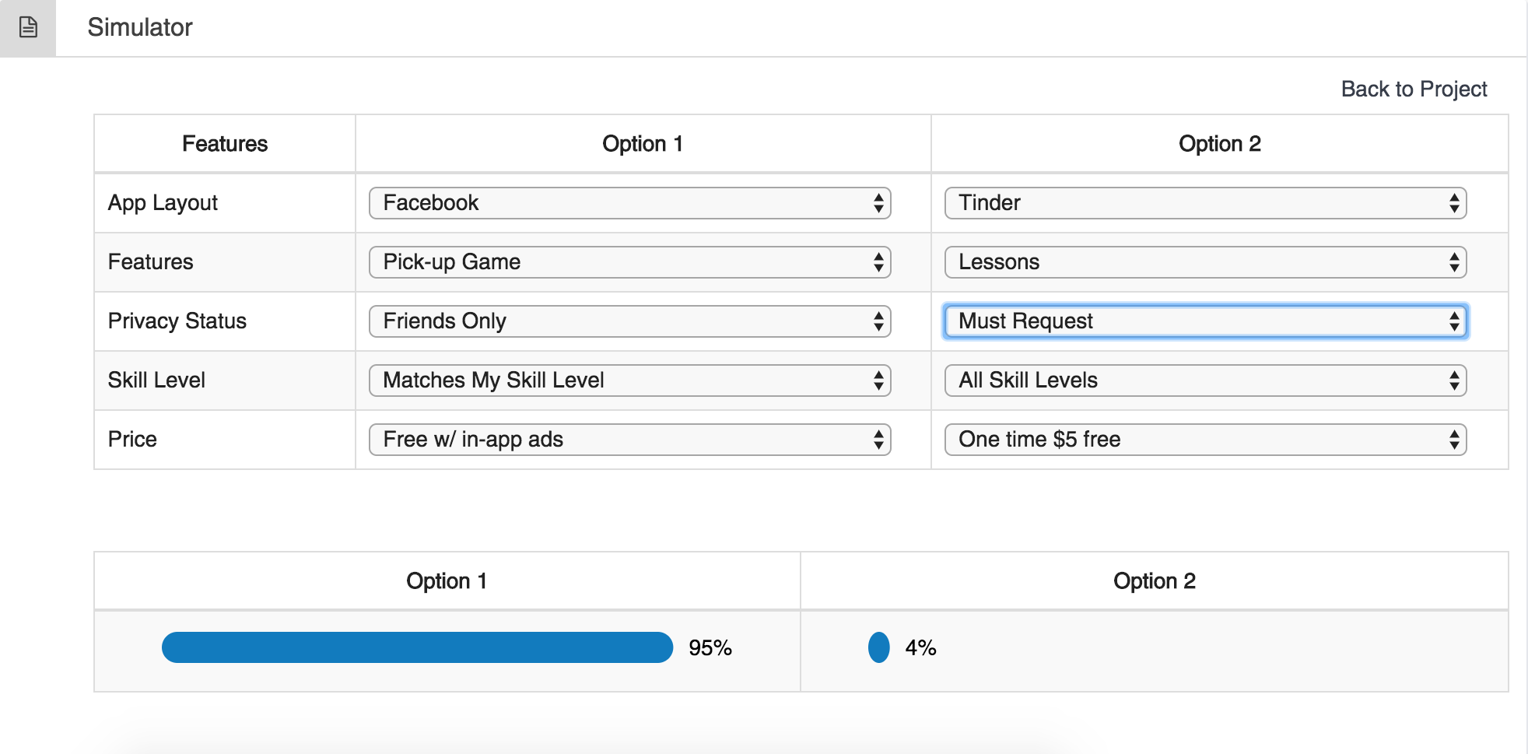Figure 10. Optimal vs. Worst combinations for SuperSportz

We now are able to better answer our question about pricing SuperSportz; as we see that the optimal layout would offer SuperSportz for free. The way that SuperSportz would then make revenue would be through advertisements; like those on Facebook. By knowing how to price SuperSportz it would be easier to now find advertisers to help pay for the research and development as well as the advertising of the actual app.

The conjoint taught us exactly what consumers want in our app, SuperSportz. The test confirmed what we already knew about Features and Price, but it changed our direction on App Layout and Privacy. Without the conjoint, we would have created a product that would have not reached to the maximum number of users. We also learned that feature and price are very important to our users. This is a great insight because it now shows us what we should focus most on perfecting.

**Research Objective: Verify Interest**

In order to analyze how each variable affects the customers’ willingness to download (WTD) SuperSportz, and how they affect WTD together, we set up a multivariate linear regression. The dependent variable we tested was *likelihood of download* (Q27). We choose this because the whole point of the original survey was to test how many consumers would be interested in this app. We looked at the relationship between this and the following: *difficult of finding others to play sports/activities with* (Q9), *interest in playing competitive sports* (Q15), *how likely would you use an app that facilitates non-competitive pickup games or meet-ups for sports/activities* (Q24), *How likely would you be to recommend this app to your friends and family* (Q28), and *how often would you use this app* (Q33).

After running the regression, we concluded that five variables attribute to 63% of the change in WTD (Adjusted R2 = 0.631), which is a large amount. A closer look reveals that the two biggest drivers of WTD are *likeliness to use an app that facilitates non-competitive meet ups* (Q24) and *likeliness to recommend this app to others* (Q28). These both make sense because each variable tests the likeliness of using an app such as this one. A one unit change in either of these two variables leads to a 1.7-unit change in the WTD, holding all other variables fixed. The next two biggest drivers are the *difficulty of finding others to play sports with* (Q9) and *interest in playing competitive sports* (Q15). These also make perfect sense because if someone has a hard time finding others to play with and at the same time, they want to play more sports, they would appreciate an app to help them make the process smoother. A desire to play more competitive sports leads to a positive 0.6-unit change in the dependent variable. The other variables also lead to changes in WTD, just not as large as those before mentioned.

Again, *frequency of playing sports* (Q5), one of the variables we thought would be the biggest key driver, turned out to be very insignificant. We thought that if a user played a lot of sports, this app will help simplify his or her life. But through the test we found out the opposite. A one unit change in frequency only leads to a 0.02 change in WTD. We infer that this is because those who play a lot of sports are comfortable with the way they do currently and don’t want to switch their methods over to an app. It is actually those who are looking to play more sports than they currently do that would download SuperSportz. Another big surprise is that we discovered that age is not important in determining who will use the app. There were people in their 70s that took the survey and said they will play the sports with other friends. We thought this app would be a hit among only the college age kids that are constantly on social media, but turns out that all ages would find use from this app.

With the Multivariate Linear Regression, we were able to test how multiple variables affect the dependent variable of WTD, both together and individually. The test showed us that the consumers likeliness to use the app for certain specific features, is a big driver of them downloading the app and using it. We found that consumers would download SuperSportz no matter what was included, if it included one of their favorite features. The other biggest surprise was that their WTD is not dependent on how often they play sports. We originally thought this would have been one of the biggest drivers of downloads. The multivariate regression was very influential in leading us to what does and doesn’t affect the final goal of consumer downloads and the interest people have in the app.

**Research Objective: Target Market**

To better group our data and find out how we should segment our market, we used a cluster analysis. The purpose of this test was to group data into clusters that are similar to each other, so we could answer our question; Who is the target market for SuperSportz? In this test, we looked at four major variables: *frequency of playing sports/activities, difficulty of finding others to play these sports with, number of user’s friends who play sports/activities,* and *download intention.* With clustering, there is no right solution, but through the algorithm we used, we found the three main clusters of those surveyed.

* Sport Hater: Our first cluster is made up of those that play sports very infrequently and have a little number of friends wanting to play sports. When looking at these users’ *frequency of playing sports* and their *number of sport playing friends*, we noticed these two variables scored lower than the other clusters. Because this cluster doesn’t like to play sports and is not exposed to it through their friends, they also have no need for an app that would help them play sports.
* The Ultimate Athlete: Our second cluster is made up of those that have no problem finding others to play sports with and play sports often. These people have very little need for this app. We know this because in looking at the data for this cluster, their difficulty variable is significantly lower than the other two clusters. Because they do not have a hard time finding friends to play sports with, they also do not have much of a need for an app like SuperSportz.
* The Wannabe Athlete: Our final cluster and largest cluster is made up of people that love sports, however they don’t play as often as they would like. We can infer this from the data and we see that this cluster frequently plays sports and though have a lot of friends that do so as well, they still find it difficult to find others to play with. Their willingness to download was also a lot higher than those of the other two clusters. Because of this, this cluster is always looking for easier ways to play sports and they would benefit from an app like SuperSportz.

Of the three segments that came out of the cluster analysis, we know that the third cluster is going to be our love group and target market. We want to target this group because we know they have immediate use for the app and will help us to grow our brand. As SuperSportz grows in popularity, we think we can focus less on marketing to our love group, and market more towards those in the middle, those who play sports but don’t see a need for the app now. We hypothesis that this group will see the popularity of the app and the new trend of organizing pick-up games through the app. They will then see that to stay with the current trends, they too must use SuperSportz. And finally, we hope that the first cluster, those that don’t play sports, will eventually decide to download the app because of the social aspect and that it is popular.

We also wanted to better understand what age would be interested in competitive sports. We found that the ages in the early-twenties are more likely to be interested in playing competitive sports than other age groups. (Chi-Square=128.62, P-value < 0.05). This shows us that our target market is going to be young, and probably in college. We also see that this target market is looking to play competitive sports with one another and because of this are looking to download SuperSportz.

**Conclusion**

To conclude, we have found that SuperSportz would be a successful app to help connect young adults who are looking to play recreational and competitive sports more frequently with others who would like to join them. However, to launch SuperSportz, we would first need to make this app exclusively for those who want to play more sports than they currently since that is the only conclusive reason people would download this app. We would then need to run more conjoint analysis on features that would be included and deliver it only to our target market, now that we have established who that is. The future conjoint would go into more detail of how these competitive sport meet-ups would happen and how the app would best manage them.

We also plan on further analyzing what type of app layout people would prefer; though we found through the conjoint analysis that people prefer a layout like Facebook over that of Tinder; this is vague and we can run AB tests and test if the differences are statistically significant until we optimize consumers’ satisfaction and the app is user-friendly.